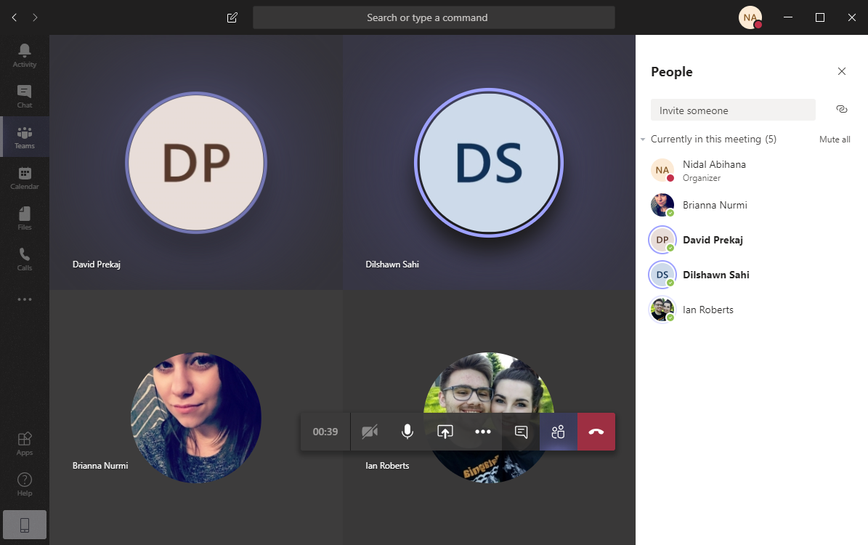

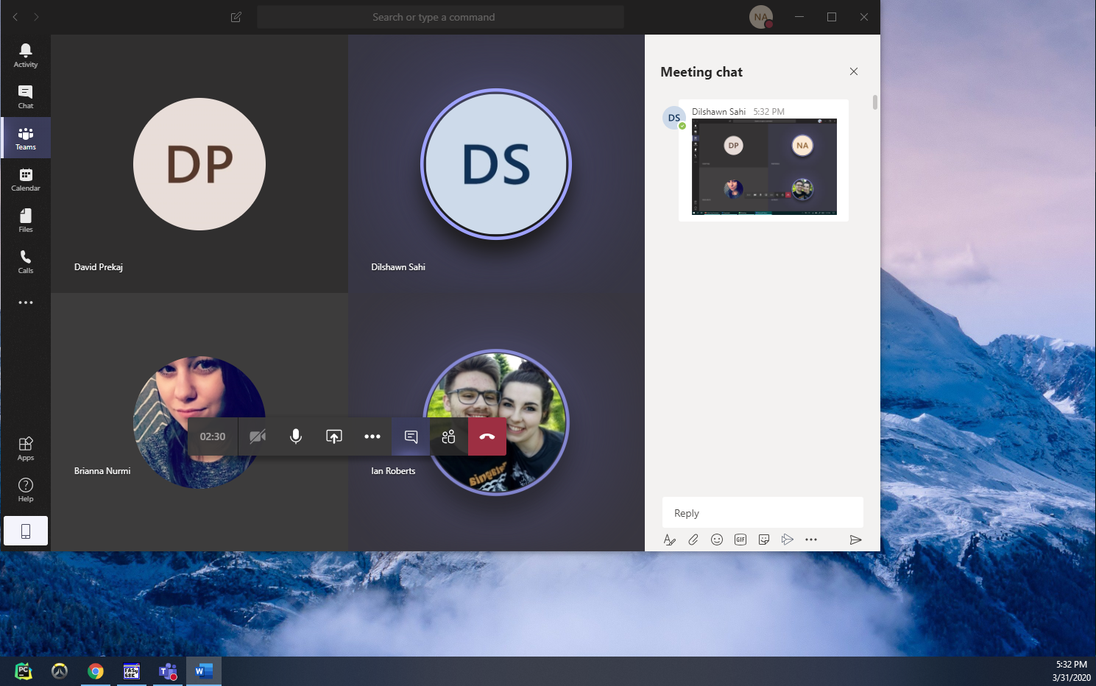

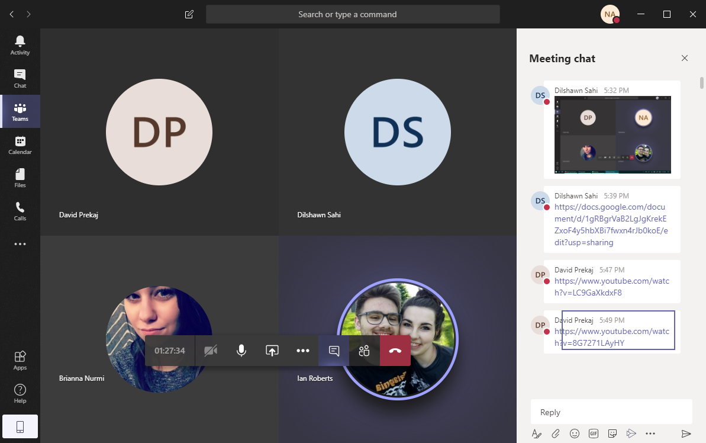

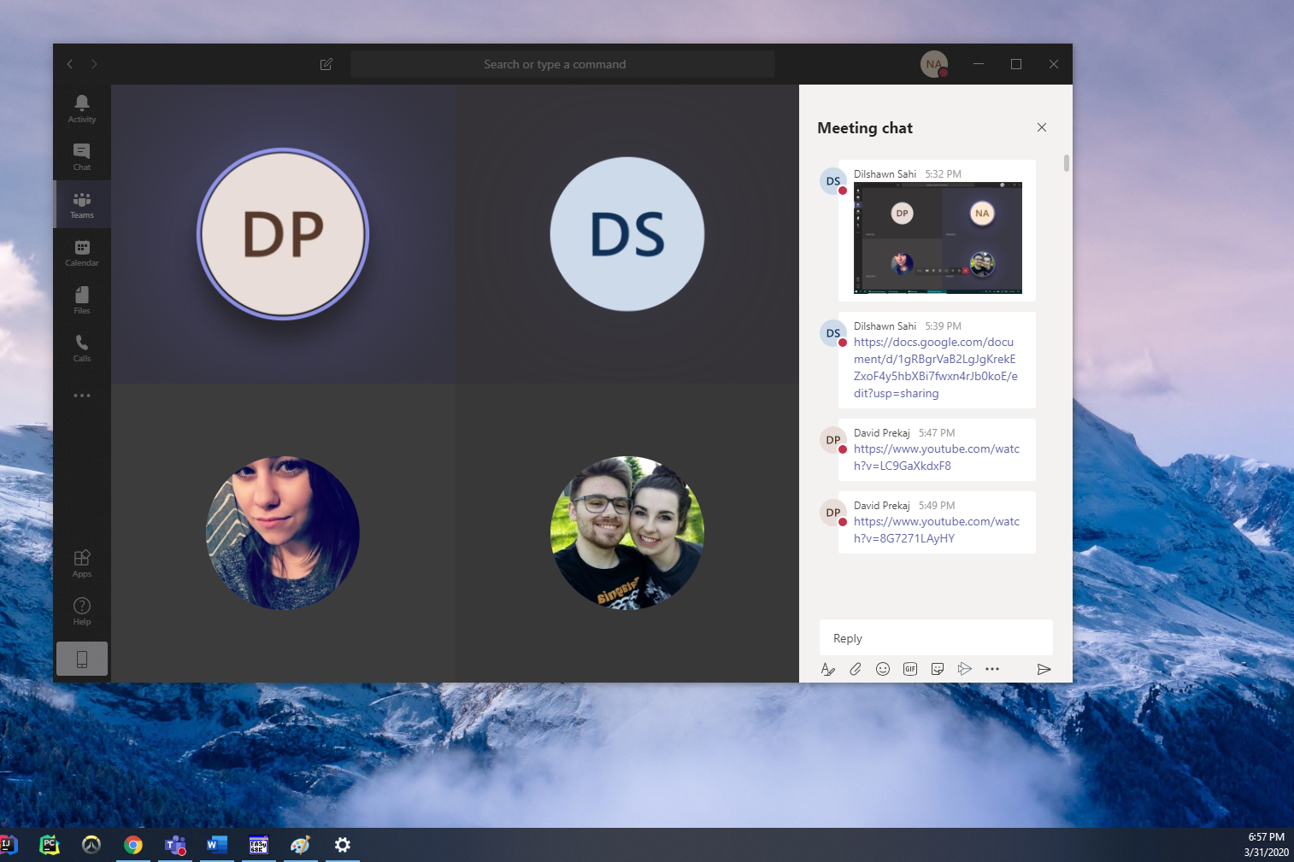

Sprint 3 Meeting Minutes

Goals for Sprint 3:

1. Email verification (Bri)
2. Comment on posts (Shawn)
3. Rating system, 1 - 5 stars for example one each post (Shawn)
4. Session.php file to keep a user session throughout page navigation (David)
5. Page to view and read documents (Shawn)
6. Profile page to add picture and bio, display users own posts(Nidal)
7. Add functions to connect.php for verifying username and email are unique. (Bri)
8. Add functionality to upload text documents instead of writing on the website.(Ian)
9. Get Search bar functional: Users, posts, tags & genres(Ian)
10. Set up an option for browsing/exploring page for  posts/users (Nidal)

Updates:

* Cannot link facebook/google sign in option.

Helpful links:

* <https://www.codeandcourse.com/login-system-using-php-with-mysql-database-with-session/>
* <https://www.youtube.com/watch?v=LC9GaXkdxF8>
* <https://www.youtube.com/watch?v=8G7271LAyHY>